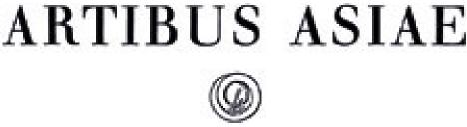

The Decoration of Some Mirrors of the Chou and Han Periods Author(s): A. Bulling

Source: *Artibus Asiae,* Vol. 18, No. 1 (1955), pp. 20-45 Published by: Artibus Asiae Publishers

Stable URL: <http://www.jstor.org/stable/3248836>

Accessed: 29/03/2011 15:08

Your use of the JSTOR archive indicates your acceptance of JSTOR's Terms and Conditions of Use, available at <http://www.jstor.org/page/info/about/policies/terms.jsp>. JSTOR's Terms and Conditions of Use provides, in part, that unless you have obtained prior permission, you may not download an entire issue of a journal or multiple copies of articles, and you may use content in the JSTOR archive only for your personal, non-commercial use.

Please contact the publisher regarding any further use of this work. Publisher contact information may be obtained at <http://www.jstor.org/action/showPublisher?publisherCode=artibus.>

Each copy of any part of a JSTOR transmission must contain the same copyright notice that appears on the screen or printed page of such transmission.

JSTOR is a not-for-profit service that helps scholars, researchers, and students discover, use, and build upon a wide range of content in a trusted digital archive. We use information technology and tools to increase productivity and facilitate new forms of scholarship. For more information about JSTOR, please contact [support@jstor.org](mailto:support@jstor.org).

|  |  |
| --- | --- |
|  | *Artibus Asiae Publishers* is collaborating with JSTOR to digitize, preserve and extend access to *Artibus Asiae.* |

A. BULLING:  
THE DECORATION OF SOME MIRRORS  
OF THE CHOU AND HAN PERIODS

ALTHOUGH THE DECORATION OF MIRRORS OF THE CHOU AND HAN PERIODS  
has often been described and its style analysed, hardly enough attention has been given to  
an investigation of the factors which determined their particular shapes and decorations.  
Such an approach may seem rather hypothetical or fancyful. However, a close examination  
of patterns on mirrors and also on other works of art has convinced me that they were  
meant to be copies of objects or of decorations made in a different material. This means  
that a certain sort of realism is the basis of many forms and decorations in ancient Chinese  
art. Though there are a number of patterns and objects which can be identified with their  
respective prototypes without great difficulty, this is generally not easy because we have not  
yet learnt to see the visual features which provide the evidence for our conclusions in the  
right perspective. The reason why the actual significance of patterns and shapes has often  
been misunderstood is the fact that such an investigation demands a new and objective  
appreciation of shapes and patterns, which, at first, presents us with great difficulties. We  
are handicapped perhaps more than by anything else by preconceived ideas based on tra‑  
ditional views as to the purpose and function of decorations and patterns.

In any consideration of the realistic basis of ancient Chinese art it should not be overlooked that the people of that time had an altogether different idea of what constitutes a 'realistic' or better a 'truthful' representation. From a technical point of view our failure to understand the 'realistic' basis of many decorations is certainly understandable. The idea that three-di­mensional subjects could be reproduced graphically in two dimensions and yet give the illusion of depth and space lay outside the range of vision of the people of those days. However, they had developed methods of their own by which they were able to indicate certain basis factors relating to depth, distances and so forth, and these may be of general importance for archaeological studies.

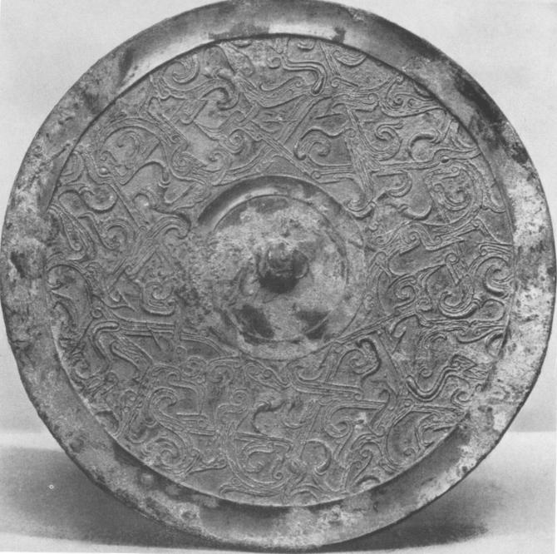

Fig. i Bronze Mirror. Di.: 17.9 cm.  
*Coll. Raymond A. Bidwell, Springfield, Mass.*

In order to fathom the difference between our approach and that of ancient China to art it is well to remember that, at least up to the end of the Han period, artists were limited in their choice of subjects to forms, patterns or events connected in some way with religious rites, festivals and ceremonies. In fact, ancient Chinese art cannot be understood except as part and parcel of rites and ceremonies in their widest meaning. The spiritual origin and for­mative agents of all these activities are cosmological and religious conceptions and these determine the meaning of shapes and patterns. Discussion of the meaning of mirror patterns should, therefore, be preceded by the examination of mirrors in regard to their prototypes because only then can their significance be understood fully.

In the present paper only a few mirror types will be investigated. Fig. I shows a bronze

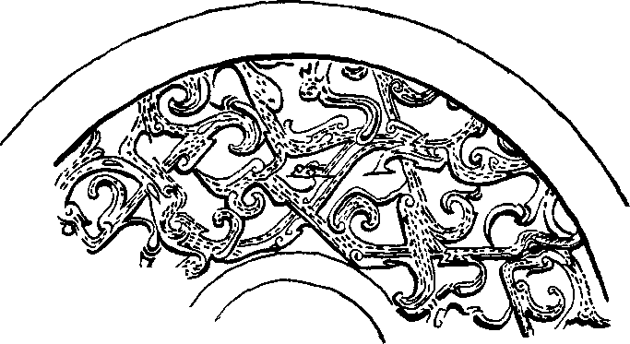

mirror of the later part of the Warring States period. It is relatively easy to see that the pat­tern on this type of mir­ror (fig. 2) is the imitation of an embroidery because each stitch is faithfully copied in metal and it would not be difficult for any needlewoman to transfer the pattern back to canvas.' However, there is no justification for assuming that only this part of the mirror was a copy. The piece of embroidered cloth was apparently stretched in a frame consisting of two concentric rings whose concave shape suggests that

Fig. 2 Detail of Fig.

|  |  |  |  |  |  |
| --- | --- | --- | --- | --- | --- |
| AA | X1111  Stk  1 A | 11 | la  1) TaN?rttoTois  t‘ il It  0011  *JJA* 12=4, 3 | | |
| **Ri**  A | W-L  AL  **1 t 1 It**  **li**  A 24 | | | **3** | **1r I**  **till I t**  eti"T 1  **0t1** |

Fig. 3 Typical Feather and Curl' Pattern

they were made of split bamboo. The central piece with a knob was then attached to the middle of the embroidered part, and the first con­clusion to be drawn is that the mirror imitated a light disc which, as the stitches show, cannot have been much bigger than the actual mirror. 0. Karlbeck2 once called the pattern in (fig. 3) "the father of all decorated mirror patterns ". This type of decoration is, however, also used on bronze vessels and other works of

1 Cf. S. Umehara, *L' etude sur les mirroirs anterieurs a la dynastie des Han',* 1923, Pl. 5 another good example of this 'embroidered' type.

2 a Karibeck, 'Notes on some Early Chinese Bronze Mirrors' *China .bourn. of Science & Art,* IV, 1926, p. 3 ff.

art and in Chinese publications on mirrors it is mostly called: 'feather and curl', or 'feather and pearl' or less usually 'feather and fur' pattern. Modern scholars often reject the names given to patterns by Chinese scholars and blame them for being unwarranted inventions of the Sung or later periods. Professor Karlgren,3 (H. & H. p. 31) for example, prefers the general term of 'comma-shaped' patterns, a group which contains very widely assorted types. How­ever, the traditional name 'feather and curl' is quite justifiable. In each square in fig. 3 two feathers can be clearly seen, one upright in the lower left hand corner and an inverted one in the upper right hand corner. The dotted parts of the pattern imitate the background cloth. The design is filled in with 'curls' or parallel lines coiling up at the ends. These little whorls are mostly worked in slightly higher relief. These 'curls' are meant to imitate either split feathers (or down) or tufts of fur, or strands of wool or silk intended to look like them. The literature of the Chou and Han periods provides sufficient evidence to prove that feather cloth was very fashionable.' Ac­cording to some texts it was imitated in woven designs, because it was expensive. Mir­rors decorated with such patterns are, there­fore, models of discs covered with either real feather cloth or with its woven imitation. A wide range of feathers and down was used for such cloth, including those of the king­fisher, of peacocks, of pheasants and geese. It was used in particular for fans, umbrellas and canopies which, in addition, were often adorned with pearls or semi-precious stones.

Fig. 4 Bronze Mirror. Di.: 18,5 cm.  
Formerly *Stocklet Collection*

Another mirror type included by Professor Karlgren (H. & H. Pl. 9. C 1) in his 'comma‑

3 B. Karlgren, 'Huai and Han', *BMFEA,* Stockholm, No. 13. 1941 abbrev.: Karlgren, H. & H.

4 Cf. W. Eberhard, *Lokalkulturen im Allen China,* Reihe 65, 7 and A. Forke, *Lun-h'eng, Essay of Wang Chung.* App. p. 490 ff.

shaped' pattern group is less easy to disentangle. Its main feature (fig. 4) is an intricate web of broad bands, which can best be seen at points, where they turn into wide loops. These are decorated with light scrolls, which can hardly be seen without the help of a magnifying glass. Split feathers (or down) emerge from the corners of the loops and from underneath the bands. In some places above the broad bands in slightly higher relief clips are imitated apparently designed to keep the feathers in position. In some cases a short band links to­gether the tips of a pair of feathers. The decoration is worked on a dotted cloth seen in only a few places. In fact, there is a wealth of small motifs distributed all over the surface but these are not easy to distinguish. Apparently fine plaited strands and entwined cords were used to hold the various feathers and bands together. The feather cloth imitated on this mirror is less stereotyped than that in fig. 3 and seems to be of a more ancient and precious type composed by an individual artist. The rim of this disc is straight and more like the image of a wooden hoop than a bamboo frame. Even if the feathers were relatively small, the size of the orginal model must have been considerably bigger than the mirror. The prototype of this mirror was most probably used in the 6th or the 5th century B.C. Some mirrors of the third or second century B. C. (Karlgren. H. & H. Pl. 68, G. 17) are decorated with a simple spiral pattern resembling to a certain extent the spiral design at the centre of the famous carpet found in Noin-ula. The model copied by this mirror may have been covered with a patterned woven material, with tapestry or trimmed with braids. Throughout Chinese history spirals are the signs for clouds and thunder and a similar mean­ing is attached to the 'feather and curl' patterns. The comparison of fleeting clouds with waving feathers is particularly apposite. On this mirror type as on many others is shown a motif of twisted strands which is commonly called a rope pattern'. However, so far it has not been realized that this is not placed there for purely decorative purposes, but that it actually represents twisted strands or a cord sewn on to the cloth or a stitch made in a rope-pattern.

That some background patterns of Shou-chou mirrors of pre-Han or early Han date are  
derived from textile designs was pointed out by Sir Leigh Ashton as early as 19355 (cf.  
Karlgren H. & H. Pl. 29, D. 15, 17; Pl. z8. D. 14). Some of the backgrounds are rather flat

5 L. Ashton, Some less obvious masterpieces at the Chinese Exhibition', *Apollo,* January 1936, p. i t.

and suggest a woven material, while others look more like tapestry. As a matter of fact quite a number of fragments of textiles dating from the end of the Chou and Han periods found in China and the bordering countries show designs, which we see also on mirrors of the period.

A very common motif on mirrors throughout the Chou and Han periods are scallops such as can be seen round the rim of many mirrors. These represent arcs or festoons, which can be made to stick up or to hang down. On some mirrors (cf. Karlgren, H. & H. D. 14, 15, 17) an edge runs along the outer border of the arcs indicating that the cloth, of which the arcs were made, was stretched in a light frame of bamboo to keep the arcs in an upright position. If we now consider the rather unusual shape of these mirrors, which were made to be suspended from a ribbon attached to the knob in the middle of the decorated side, then the prototype becomes obvious. A suspended disc surrounded by festoons or by a cornice-like crown of upright standing arcs represents an umbrella or canopy such as were used in all kinds of rites and ceremonies. In the art of the Han, Six Dynasties, I' ang and later periods such umbrellas or canopies are often depicted. They were dangling from a curved stick held by servants above their masters heads or were suspended from ceilings. Some were erect­ed above saints or dignitaries and in the Tun-huang caves large ones are standing in the courtyard of temples just in front of the Hall of Buddha.

The great number of mirror types shows that in the Chou and Han periods there existed a variety of such umbrellas; in fact, the materials copied on mirrors range from feather cloth and textiles to plaited straw and wood. The centre of the mirror corresponds to the pivot of the umbrella and forms the highest point of the whole construction. The main decorated zone of the mirror corresponds to the sides of the umbrella. The craftsmen imitating the umbrella in metal took their viewpoint from above, as it were, as if looking down onto the decorated umbrella cover. However, they did not use any signs showing the gradient of the incline of the cover, but it is reasonable to assume that a great number of umbrellas or ca­nopies were pyramidal or convex in shape. For instance, nobody would be able to see the beautifully worked dragons or birds (cf. Karlgren, H. & H. D. 14, 15, 17) unless they were elevated above the crown of arcs surrounding them.

A number of Chou and Han mirrors represent umbrellas or canopies with two or more

tiers. The so-called 'double mirrors' (fig. 5) represent a particular early type having one undecorated disc and above it an openwork of interlaced dragons. Professor A. Salmony has already pointed out that on such mir­rors the studs on the outer rim imitate nail-heads; these would have been necessary for the holding together of the two layers. The straight rim represents a wooden hoop and the openwork suggests that the inter­laced dragons were originally made in carved wood. Such a disc must have been more heavy and less graceful than umbrellas made of textiles or feather cloth in the later part of the Warring States period.

Fig. 5 So-called 'Double Mirror' Di.: 22 cm. By courtesy of *The Fogg Museum of Art, Harvard University, Cambridge, Mass.*

The development of these double mirrors is typical of the trend in the Warring States  
period. It can be studied in a great number of mirrors found in the Shou-chou region  
( cf. Karlgren, H. & H. Pl. 4o ff.) In all of them the lower 'wooden disc' is replaced by a

|  |  |
| --- | --- |
|  | light structure covered with some 'textile material', and the heavy openwork carved dragons are re­placed by a lighter layer of dragons or dragon-arabesques made of leather or some other light material.  A remarkable type of mirror which is usually cover­ed with a 'feather cloth' pattern has a superstructure consisting of star, swastica- or wheel-like shapes, which apparently was made of wands or bamboo sticks and ropes or leather straps slung round tops |

Fig. 6 Detail (cf. Karlgren, H. & H., P1.18, C. 53) of the umbrella stays (these will be discussed later)

6 *An Exhibition of Chinese Mirrors.* Chinese Art Society of America. 1951, Catalogue.

projecting above the underlying cloth (cf. Karlgren, H. & H. P1. 18) (fig. 6). What Karlgren calls 'flail-like endings' are attached to the ends of the spokes or points of the stars. These represent streamers made of leather or other materials swung round by a rotating motion; on some mirrors they fly clockwise and on others anti-clockwise. However, whether the streamers were only sewn to the umbrella cover so as to give the impression of revolving movement or whether the umbrella was set rotating and the streamers actually made to swing round, is difficult to tell. However that may be, an umbrella covered with a net made of ropes or ribbons may be likened to a miniature predeccessor of 'string-towers' such as are still erected in the Na-khi kingdom' as defence against evil spirits, the more so, as mir­rors sometimes served a similar purpose.

Fig. 7 shows a mirror of a type produced especially in the second part of the Western Han period and in the beginning of the first century A. D. In the major zone clusters of cones connected by threads represent constellations, similar to constellation pictures found on reliefs in the Eastern Han period. This type is called 'star and cloud' mirrors. Although the specimens differ in detail, they all have two concentric circles of scalloped arcs, the one running along the outer rim, the other standing nearer the centre of the mirror. A similar arrangement can be found on other mirror types of the same period. This double row of arcs is important because it corroborates that the mirrors copy a convex construction, for if they imitated flat discs, the interior small crown of arcs would be completely hidden from view by the exterior larger cornice of arcs. This mirror imitates an elaborate construction. The boss and cones in the centre form the apex rising above the interior crown of arcs. Slanting lines separating zones recur on both sides of the main decorated part. They are slightly raised and apparently imitate strands needed to hold together and support the various sections of the umbrella. Such slanting (or sometimes straight) lines are a common motif on mirrors. They differ, however, in detail. On some mirrors they imitate strands used as lining for light textile covers, while on others, according to the heaviness of the covering material, for the same purpose straw, bamboo or even light timber sticks are used. In fig. 7 a ring with spikes sticking out on all four sides runs round the slanting lines in the outer circle. This looks like a wire ring, which keeps the umbrella cover in shape.

7 J. F. Rock, *The Ancient N a-khi Kingdom of Southern China,* Harvard University Press, 1947, P. 389, Pl. 223.

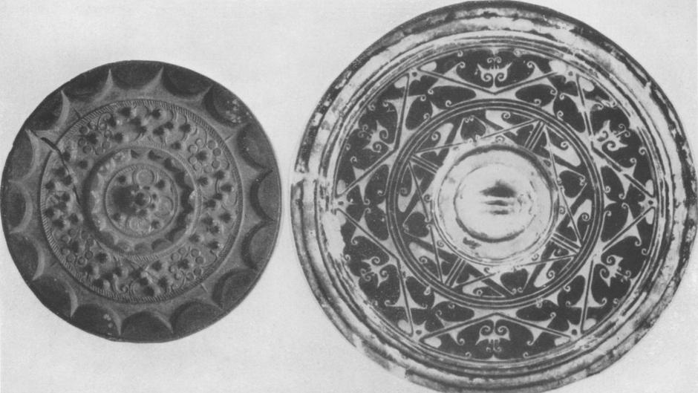

Fig. 7 Bronze Mirror Fig. 8 Pottery disc

By courtesy of *Hallroyl House, Stockholm* By courtesy of *Coll. Denis Cohn, London*

The cones and threads on the main decorated part are mounted on a plain surface suggest­ing undecorated silk, linen or another material as its prototype. Professor Yetts 8 assumes that the cones were intended as a substitute for semi-precious stones, glass or enamel. This hypothesis is supported by the fact that many mirrors show each cone set in a little cup or mount. This pattern is sometimes called 'strung pearls' and presumably such umbrellas were adorned with pearls set in a metal mount and sewn on the cloth.

Of particular interest is a pottery disc in the shape of a mirror (fig. 8), which is said to be from Hui-hsien in Honan. The pattern is painted red on a black surface and this colour combination and the general appearance make it quite clear that it is an imitation of painted lacquer. According to the Shih-ching umbrellas fixed to chariots as roofs were sometimes made of painted lacquer. Some time ago Dr. Schuyler Cammann9 drew attention to the

8 W. Perceval Yetts, *The Cull Chinese Bronzes,* London 1939, p. 115.

9 Schuyler Cammann, 'TLV patterns on Cosmic Mirrors of the Han period' *journal of the American Oriental Society.* Vol. 68. Oct IDec. 1948. p. 159-168.

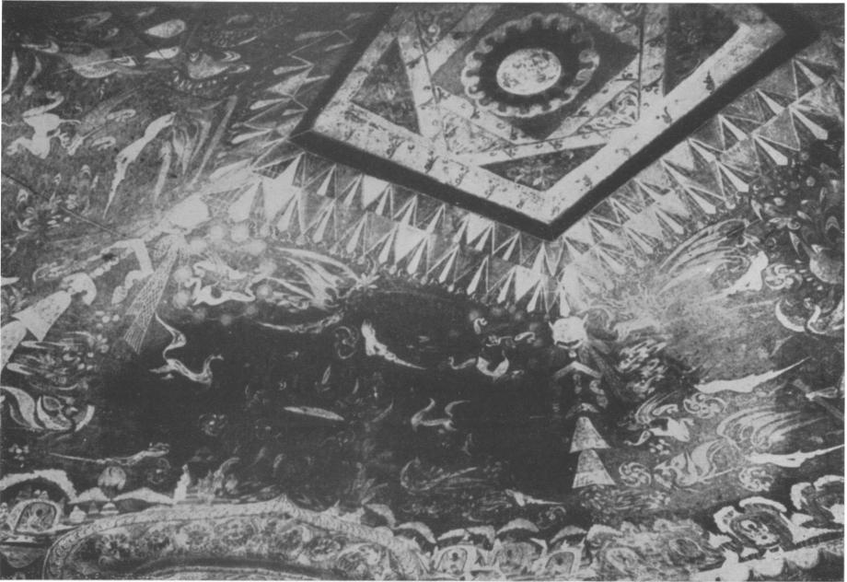

Fig. 9 Painted Ceiling, dated by inscription A.D. 538/9  
(P. Pelliot, « Mission Pelliot a, Cave 120 N. Pl. CCLVII)

similarity between some mirror patterns and painted ceilings. This pattern (fig. 8) not only confirms the close connection but shows precisely the methods by which structural parts of a roof were represented. The disc consists of four concentric zones, the first of which is the seat of the boss. The second is encompassed by a triple circle and contains two superimposed squares, i. e. the square drawn in a thin line is apparently placed above the thicker-lined square. Groups of lines radiate on all four sides from the centre towards the circumference. The third section is filled by a large zig-zag pattern and the fourth is formed by the rim. Tulip and lily-like motifs and scrolls are distributed all over the surface of the disc.

The centre seat and the fluted boss resemble the central portion of mirrors typical of the  
Warring States and early Han periods, though it is interesting to see that on this disc the

seat rises higher than on most mirrors. It is the second zone which is of major importance, because it is an exact copy of a lantern-ceiling. Although no actual roofs or pictures of roofs have survived to prove that such ceilings were known before the Han period, they are of such a simple type of construction that there is no justification for assuming that they were not introduced before the Han period. Moreover, there is enough textual evidence in descriptions of Han architecture to prove that at that time they were well known.

The painting on the disc may be compared with a painted lantern-ceiling in a cave in Tun­huang (fig. 9) dated by inscription A. D. 538. Since the timber beams are placed to form squares one above the other each turned 45° relative to the next, the roof gains height and if the upper squares are made in diminishing size, a kind of vault-or pyramid-like shape is created. At the top a square or round hole can be left open as a skylight, not unlike the opening in the top of a Mongolian yurt. Such lantern ceilings and skylights are often des­cribed in Chinese literature, for example in Chang Hang's *(Ping-tzu,* A. D. 78- 139) *'San-tu fu',* the Three Capitals *fu* (poem) and Wang Yen-shou's *(ca.* A. D. 120 -150) 4 *Lu-ling-kuan­te ien fu',* 'the Hall of Spiritual Efficiency *fu'.* They are often closed by a plaque or a sham roof decorated with a painted or carved flower, "its face turned downwards as if rooted in the sky", in fact not unlike the flower decorating the centre of the cave in Tun-huang. The two superimposed squares on the disc represent, therefore, the actual construction while the centre corresponds to the plaque or sham-roof above the skylight.

A lantern ceiling in the tomb of the *Heavenly Kings and Earthly Spirits* in Korea elucidates further the significance of the various lines. A reconstruction of the vaulted yurt-like build­ing is given in figs. 10 a and b. Although the tomb is of post-Han date it represents a pri­mitive and ancient type of construction. In fig. io a, the construction of the roof is shown from below. The largest square corresponds to the lowest square of beams serving as base for the lantern. The squares of beams are similar to those on the painted disc. The skylight, called the *Well of Heaven,* is left open. Most interesting is the cross in fig. 10 a, represent­ing four beams, which can be seen in elevation in fig. 10 b. They are slightly curved and support the lantern rising above the vaulted part of the building below. This cross of beams corresponds to the lines on the disc, which radiate from the centre to the enclosing triple circle; they do not meet in the centre because the centre plaque is fixed above them. The

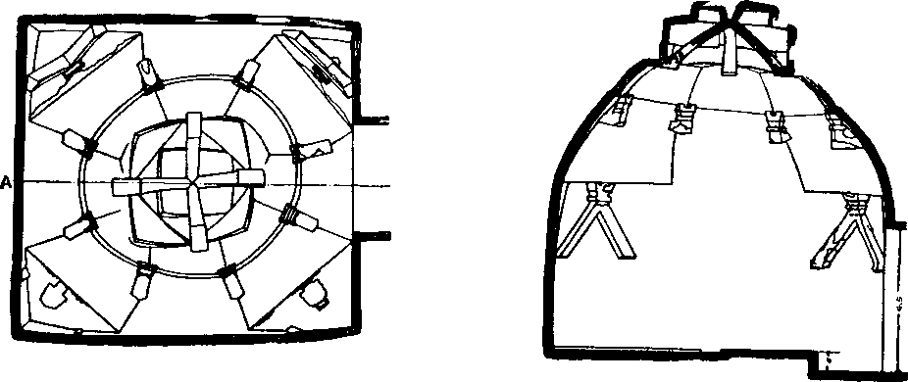

a b

Fig. 10 a and b Tomb of the Celestial Kings and Earthly Spirits' in Korea  
(T. Sekino and others, Kokuri ji-dai oseki', *Archaeological Researches in the Ancient Kukuri District, 193o,* Pt. II, p. 171)

triple circle represents the base of the lantern ceiling and corresponds to the lowest square of beams in the cave in Tun-huang. (The latter covers a square vault, while on the disc the lantern ceiling rises above a round construction). The third zone of the disc can be com­pared with the upper part of the vault in fig. t o b, or with the vaulted cave walls in fig. *9.* The flower-like motifs and scrolls do not contradict such an interpretation, as e. g. the *Lu-ling-kuan-e ien fu* mentions ceilings and walls gaily decorated with painted or carved flowers.

However, is the painted ceiling in Tun-huang really that of a building? Two rows of triangular festoons and pendants hang from the lowest square of beams and tassels dangle from all four corners. This looks like a painted canopy or the interior of a tent; the decora­tion of the actual vault resembles figured carpets or decorated felts, which often adorn the interior of tents or Mongolian yurts." Umbrellas or canopies in the shape of a building can be found all over the world and there is also evidence, which indicates that they were not unknown in ancient China. The painted disc is not the image of a building but of an

10 Entering this cave Irene Vonjehr Vincent *( The Sacred Oasis,* London, 1954, p. 88/ 89) wrote "one felt — that one had stepped into a large richly decorated tent, the lower edge of each of the four oblique ceiling panels curved back to the wall like a tent roof sagging under the weight of its heavy material".

umbrella. Although the disc is flat, this does not mean that the umbrella was also flat. The third zone was possibly slightly inclined, and the second zone raised at an even steeper angle above it, not unlike the small vault on the top of the tomb in fig. 10 b. Even to-day many umbrellas in China have a small arched super-roof just above the apex of the cover. The lines in fig. 8 represent not only the cross of beams in the building but also parts of the actual construction of the umbrella. Similar lines occur on a number of mirrors and al­ways represent cords or props connecting the lower section of the umbrella with the highest part in the centre. Their structural function is essentially the same as that of the cross of beams in figs. 10 a and b.

However, only a few mirrors of the Chou and Han periods are replicas of umbrellas made in the shape of a building. The mirror shown in fig. i i is of a different type produced in particular during the later part of the Western Han period and at the beginning of the Eastern Han period. It is typical of the artists of the Han period that they widened the scope of their work continually. They tried to imitate more and more different types of umbrellas and canopies. The more complicated the construction, the more difficult it was for them to copy them correctly. This mirror is a good example of their resourcefulness. The boss in the centre is thicker than on any of the mirrors discussed before. In principle the size of the boss is determined by the heaviness of the construction it imitates. Feather, cloth and textile discs needed only a small and delicate central support. A heavier type of umbrella needed a stronger support indicated by a thicker boss. In many cases it was too heavy for suspension and had to have a post supporting it from below.

On the basis of previous experience certain motifs can be interpreted without difficulty. The centre seat decorated with twelve flat discs surrounding the boss corresponds to the top of the umbrella. Groups of straight lines on all four sides connecting the outer edge of the centre seat with the flat discs again represent cords (or props) supporting a small elevation on top of the umbrella. The function of the slanting lines in the construction of the umbrella has been discussed previously. The next section, however, shows a new type of motifs consisting of sixteen groups of straight and curved lines connecting an inner broad ring with a ring surrounded by arcs. Four of these groups consist of three straight lines each ending in a semi-circle, while the other four in addition have their outer ends tied to

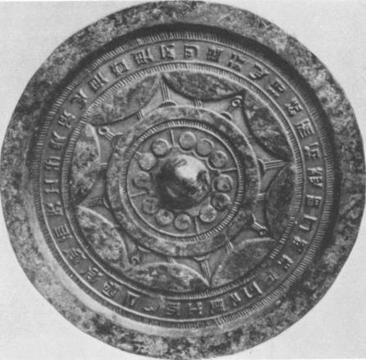

Fig. i i Bronze Mirror Di.: 18, 5 cm.

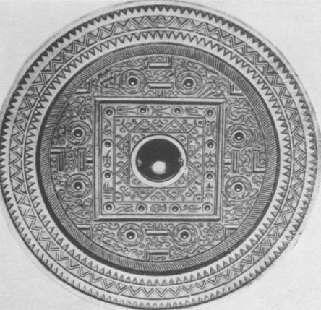

Fig. 12 TLV Mirror

By courtesy of *Robsska Konstlncljdmuseet, Goteborg* By courtesy of *Metropolitan Museum, New York*

a hook in spiral shape. These straight lines represent cords or props used for the suspension of the ring surrounded by the crown of arcs. Some are fastened to semi-circular ledges projecting from the upper ring. The remaining eight groups show slightly curved lines and represent curved brackets adding strength to the construction. All these motifs recur on many mirrors whenever a similar construction is depicted. Although they contain pictorial features, it is perhaps more appropriate to call them 'conventionalized signs', because they were used in a standardized manner. They provide a good example of methods of repre­sentations used in China even before the Han period. The mirror in fig. i i represents an umbrella tapering towards the top like a tent.

A T LV mirror of the late Western Han period fig.12 again represents a building and at the same time an umbrella or canopy; we can read the different parts of the decoration in terms of a building and of a canopy. The boss in the centre corresponds to the top-plaque, i. e. to the sham roof, and the small square to the skylight. The curved lines connect­ing the boss with this square represent curved brackets proving that the top was raised above the inner square. The diagram of a lantern ceiling is enclosed in the next portion encom‑

passed by the large outer square. It differs from the one in fig. 8 in having superimposed rectangles forming a star with eight points. The enclosing broad square with the double lines stands for the frame of beams on which the lantern rests. The cross in the centre has disappeared but the T-signs on the four sides of the square still mark the ends of the four timber beams. Actually a round plaque (e. g. clearly to be seen in photographs of the Tomb of 'the Celestial Kings and Earthly Spirits') or a T-shaped horizontal bar is often butted-on to the end of the four beams fixed to the vault outside the lantern ceiling (figs. a). The next zone of the mirror is decorated with the signs of constellations, immortals and clouds, and this portion corresponds to the vault of the cave (fig. 9), which is also decorated with pictures of constellations, star-gods and cloud signs. Of particular interest are the four V-signs, because they are the images of triangular-shaped wall brackets (figs. r to a and b), while the L's correspond to L-shaped props such as can be seen in figs. to a and b in the upper part of the vault. The outer border of the mirror with its chevron pattern can be likened to the decoration of the lower parts of the vaulted tomb.

Other structural parts of the building are incorporated in the decoration. The boss in the centre, which symbolizes the *rai chei, i.* e. the 'Great Ridgepole', the axis of the universe, corresponds to the central post of the building. The twelve studs, sometimes called by the Chinese nipples or sticks (mei), are images of smaller posts which surround the square in the centre of the hall, not unlike posts standing round a raised platform in temples of a later period often supporting a canopy. The eight studs in the outer portion represent posts standing like gate-posts in pairs on each side of the square.

However, there are a number of points which show that this mirror is the image of a canopy. The squares and rectangles represent frames made of bamboo or some other light material. The interior square is connected with the rectangles by eight groups of straight lines (two on each side), each again fixed to a ledge of semi-circular shape. This proves that the rect­angular frames were suspended from the square above and supported from below by a number of curved brackets (curved lines) standing on the larger square frame. This whole structure of superimposed frames rises above the convex-shaped actual umbrella or canopy cover. The boss in the centre represents the top of the pivot of the canopy and the smaller studs the ends of umbrella stays supporting the canopy from below. In tombs

|  |  |
| --- | --- |
| of the late Chou and Han periods bronze stands of canopies and the decorated ends of umbrella stays have been discovered." The latter often end in cones, hemispherical bosses or quatre-foils closely resembling studs on some mirrors. There are some signs which show that the eight studs in the main zone imitate stays rising above the surface of the canopy cover: each cone is surrounded by a ring and the groups of lines radiating from the centre again prove that the outer circle re­presents a ring, which was suspended from above by cords. Flying streamers are imitated by four lines issuing from |  |
| Fig. 13 Wu or Yiieh Mirror Di.: 11,5 cm. Formerly *Ostasiatische Kunstabteilung, Museum, Berlin*  the centre of each stud demonstrating that the circle |

represents an open ring and not a solid disc. Each of the cones is mounted in a shallow cup. The slanting lines surrounding the main zone are heavier than on previous mirrors and ap­pear to represent bamboo splints (or straw) serving as structural basis for the various layers of the canopy.

Very few mirrors are images of canopies or umbrellas designed as a building. One mirror type is, however, of particular interest; this is the so-called *Wu* or *neh* mirror, which was made from the second century A. D. onwards in the coastal region of Southern China. The large boss (fig. 13) indicates that the canopy, of which it was the copy, is a heavy one and the main decorated zone with its deep relief suggests that it is the image of a carved wooden disc. In this case it seems fairly certain that the construction had to be supported by a central post. In terms of a building: the boss corresponds to the apex of the roof, the carved portion to the vault of the building, either a round tower or a round hall. The most interesting part is the next zone: a band decorated with semi-circular arcs in high relief,

11 Yoshida Harada, *Skina Koki Zuko,* Part 2, Pl. XIX, XX.

which alternate with flat squares. This band represents the base of the roof construction and the semi-circular arcs stand for the ends of posts or pillars half hidden in the wall; the squares are the ends of brackets placed on both sides of the posts. The patterns on the rim of the mirror again correspond to the decoration of the walls. The type of building imitat­ed in this canopy is thus very different from those on the other mirrors. It may be suggested that this more solid type of building was typical of the architecture of the Southern regions of China, while the lantern ceiling, tent or yurt-like constructions, were more favoured in the Northern and North-western parts of China.

The decoration of this mirror can also be interpreted in terms of a canopy. The carved portion was probably convex and was encompassed by a broad band. The semi-circular motifs and the squares mark the end of stays and props supporting the heavy cover from below.

It is to be expected that a study of the various mirror types of the Chou and Han periods will provide us with a knowledge of a great variety of different types of such canopies or umbrellas. However, each mirror merits a separate examination.

*Umbrellas and Canopies*

There is some justification for the selection of just these ritual objects as models for mirrors. Not only in China but in many parts of Asia canopies and umbrellas were symbols of sacred power and authority from earliest times onwards. They were used in religious ser­vices, state ceremonies, pageants, processions and family rites. As in our own civilization the vault of the sky is called in China *the Canopy of Heaven, the Azure Canopy,* and this is not a mere metaphor but assumes material form. Umbrellas and canopies were images of the sky and were appropriately decorated with cloud and thunder patterns, constellation signs, and the myriads of stars represented by small nodules and by dotted cloth.

The great importance of canopies and state-umbrellas is reflected in the *Chou-li 12,* in which the duties of officials appointed to look after them are outlined. Their decorations apparently varied according to the particular audiences, rites or receptions, in which they were used. Their sizes may have ranged from small ones, which could be carried by one person, to larger

12 *Le Teheou-li* trans'. by E. Biot, Paris 1851, Vol. I, p. 116 ff.

ones placed in a hall and to big constructions, which could only be erected in the open air. In the *Han-shu"* a machine is mentioned, with which canopies could be raised or lowered. Even in our own time, in the East and the West, canopies and umbrellas are used in the most solemn celebrations of church and state and imbue those standing under them with a sacred power.

In ancient China, according to the *Chou-li* and descriptions in other texts, umbrellas and canopies were often made of decorated felt or plain, embroidered or figured silk. They were decorated with feathers, plumes and down and some were even adorned with mother-of-pearl, pearls or semi-precious stones. Other materials mentioned include rushes, leaves and, most important, bamboo.

Moreover, such canopies or umbrellas had a definite social function as signs of rank and honour. In the Chou and Han periods they were sometimes presented by the rulers to vas­sals and visitors. Feather umbrellas are listed, for instance, in the Eastern Han period among Ming-ti's (5 o A.D.) imperial gifts to the chief of the Hiung-nu. Up to the present time so-called 'presentation umbrellas' of richly decorated silk were favoured as gift to popular of­ficials. In the Chou and Han periods their replicas, the mirrors, served the same purpose and we find them listed e. g. among presents sent by the famous *Tscao Ts' ao* to the Im­perial Court. Moreover, such mirrors could be exchanged between friends providing a charming gift.

A canopy or umbrella was often fixed to a chariot or carriage enhancing its splendour and serving as a roof. According to the *Chou-li"* the square chassis of a ceremonial chariot re­presents the earth, the round umbrella the sky, and the twenty-four festoons lunar mansions. There is a wealth of evidence showing that clouds and constellation signs were the most common motifs on umbrella and canopies whether used in halls, processions or on a chariot. According to a commentary of the *Chou-li* the number of arcs surrounding the rim of such umbrellas was determined by the constellation on its main portion. For example, an um­brella decorated with the sign of the Red Bird, the constellation of summer, would have seven arcs, while one decorated with another constellation required only six. However,

13 *Chien Han-shu. History of the Former Han Dynasty,* chap. 99, 15 b.

14 *Op. ca.,* Vol. II, p. 488 ff.

cosmological speculations on numbers loomed in the minds of a few scholars more than were actually applied to everyday life. The description of the decorations of umbrellas and canopies in the *Shih-chi, Chou-li, Han-shu* and in a number of poems, for instance in Chang Heng' s *San-tu fu',* all sound very much alike. The canopy of Kao-tzu,15 the first Emperor of the Han dynasty, was made of yellow silk and adorned with plumes, while that of the Empress was decorated with pheasant feathers. How elaborate these constructions can be is reflected in the description of a canopy over one of Wang Mang's (usurper of the throne A.D. 9-23) chariot drawn before him in procession: it was ninety feet high and had nine tiers. 16

In mourning ceremonies and funerals umbrellas and canopies played an important role. Even in modern times they are carried in funeral processions or set up by friends along the route of the procession as a special honour to the deceased. In the *Li-chi"* a canopy erected over the coffin of an emperor is described: it had an embroidered top of white silk and above it a sham roof was attached to it by six purple ties. It may not have looked very different from the top of the umbrella represented on the mirror in fig. ii. According to the *Li-chi"* these canopies were not the same for different clans, peoples or regions: e. g. those of the Yin (Shang) clan had a tent-like canopy made of carnation-coloured silk de­corated with clusters of ants on all four sides, while the people in Wei had linen ones, and the Lu people canopies of white silk. In modern times, e. g. in Shantung," an embroidered silk umbrella is sometimes placed over a coffin.

In tombs of the Chou and Han period remains of canopies or umbrellas have been found, and, according to the *Hou Han- shu,"* Ling-ti, an emperor of the Eastern Han period, ( A. D.168-189), placed a canopy covered with blue feathers in the tomb of one of his con­cubines. Mirrors could be used in all these cases as a substitute, and this is the reason why they were often suspended from the ceiling, a custom which survived in temples up to

16 H. H. Dubs, *The History of the Former Han Dynasty,* Baltimore 1937, Vol, I, p. 85.

16 Information kindly giyen me by Prof. Dubs, Oxford.

17 Li chi (tr. J. Legge, *Li Ki,* 1885, chap. Sang Taki, sect. 2, 37, p. 197).

18 *Ibid.,* p. 140.

19 P. L. Kalf, 'Totenkult in Slid-Schantung', *Katholische Mission,* Yen-chou, 1932, p. 69.

20 *Hou Han-shu', (History of the Later Han Dynasty),* chap. 16, I, 10.

modern times not only in China but also in Japan." Mirrors were also suspended from the lids of coffins, also as substitute for real umbrellas, and even in modern times these mirrors were decorated with the sign of a constellation, usually the Dipper."

There seems to have been a special reason, why canopies and umbrellas were made in the shape of buildings. According to several poems the halls and towers with lantern-ceilings, skylights and sham roofs were used in particular as 'spirit-halls' or 'spirit-towers'. Through services held in them it was hoped to establish contact with benevolent spirits who, accord­ing to common belief, preferred lofty halls and high buildings as their abodes and were at­tracted even more when these were decorated with signs and pictures of their home region and of themselves." As these spirits live in the sky, rest on stars, and roam through the end­less waste of the celestial spaces, the decoration cannot have been very different from those on mirrors. However, prayers, music and dances were necessary to induce the spirits to attend the services. It was hoped that mirrors being the image of 'spirit-halls' or 'spirit towers' attracted these spirits in a similar way and served them as abode. This accounts for their magic qualities. It should be remembered that shamans in Northern Asia up to this very day carry similar mirrors in their hands or have them sewn to their garments when calling down helpful spirits, whom they still attract by music and dancing.

In ancient China the conjuring-up of spirits could be done in tent-like buildings as well as in halls or towers. In Chang Hang's *Wsi-ching* fu' the poem of the 'Western Capital', just before the beginning of the great spectacle, the *Ting-lo kuan',* the 'spirit-tent', was erected for the Emperor and it was decorated with kingfisher feathers, pearls and precious stones. In the Tang period, according to paintings found in Tun-huang, temple dances still take place in front of canopies sometimes resembling a yurt in construction. The mirrors of the Chou and Han periods were found in tombs of noble families or wealthy people and most

21 Schuyler Camman, 'Suggested Origin of the Tibetan Mandala Paintings', *The Art Quarterly,* Spring 195o, mentions a poor copy of a rang mirror suspended from the ceiling of a canopy in the Kanzeonji temple in Fukuaka and Miss E. Lyons (' An Exhibition of Chinese Mirrors', *Bulletin Vereenigung van Vrienden der Aziatische Kunst,* June 1951) refers to a mirror placed on the ceiling of the West Pagoda in Manchuria and another one set into the ceiling of the Hokkedo Sangwatsudo in Nara.

22 Kalf, *op. cit.,* p. 36.

23 *Shih-chi,* transl. by E. Chavannes, *Les Memoires Historiques des Se-ma Ts' ien,* Vol. III, P. 470.

probably imitate umbrellas and canopies used in their own family rites preferred perhaps in the localities in which they lived. In modern times a tent is sometimes set up in the court­yard of a house, in particular at a time of mourning; this may by a relic of the ancient 'spirit-tent', the more so as dances and shows took place inside or in front of it.

Some of the decorations on mirrors suggest that the prototypes were round buildings or towers. These were possibly the predecessors of Buddhist pagodas constructed round a central pole piercing the roof and topped by a *shattravali* consisting of tiers of discs or rings symbolizing the superimposed regions of heaven. A similar meaning seems possible for the various tiers of umbrellas and canopies.

However, the decoration of these mirrors imitates canopies and umbrellas and not the actual buildings. They are 'spirit-canopies' 24 referred to in Chinese texts, especially in the *Shih­chi."* According to hymns some had as many as nine tiers and were set up in the centre of the hall just underneath the apex with the skylight.

*Meaning*

These mirrors are called 'cosmic mirrors' because their decoration reflects the cosmic order either in part or in its entirety. Of the many mirror types those decorated with the signs TLV have aroused the keenest interest. It is rather doubtful whether these mirrors were ever used as sundials; however, Professor Yeas' " interpretation of the L-and T-signs in connec­tion with time and space is corroborated by other factors. The V's represent the four corners of the universe and the beginnings of the four seasons. Their ancient meaning is still reflected in some paintings in the caves of Tun-huang,27 where the pictures of the Four Guardians or Kings presiding over the four corners of the world, are still placed in V-like

24 Banners, standards, flags are often mentioned in Chinese texts of the Chou and Han periods. It should, however, be realized that the translation of the Chinese words in European languages is rather inaccurate. We understand under 'banner' a post with a flag, but the so-called 'spirit-banner' is clearly described in some hymns as having nine tiers, it would thus be more appropriate to translate it with 'spirit-canopy' or 'spirit-umbrella'.

25 *Oft. cit.,* Vol. III. Appendix, e. g. pp. 612 and 625.

26 Yetts, *op. cit.,* p. 118 ff.

27 Cf. P. Pelliot, *Mission Pelliot, Les Grottes de Touen-kouang.* P1. XXX and XXXI.

signs in the four corners of vaulted caves. The L's stand for the four points of the com­pass and for the equinoxes and solstices. The V's and L's are time-space nexus signs. However, such a division of time into eight periods can be applied to all recurrent time units. This 'thinking in cycles' of recurrent natural phenomena is typical of ancient China, and the signs on the mirrors can thus be interpreted in terms of many different time units, e. g. one year, twelve years ( Jupiter cycle), other astronomical cycles, or the cycle of human life and death or even world-ages.

Dr. Schuyler Camman interprets the L's as signs of movements and directions connected with the change of the seasons. In fact, the L's may be compared with the arms of the swastica-like signs representing a rotating movement. (cf. Karlgren, H. & H. Pl. 18). The complexity of possible interpretations can only be grasped, if it is understood that Chinese cosmological speculations are based on the idea of the solidarity between the universe and man: the celestial sphere has its terrestrial counterpart and heaven, earth and man are of the same substance. The order on earth must correspond with the order of the universe.

Only a few aspects of this symbolism can be given as it applies to the decoration of these mirrors. Concentric zones on T LV mirrors and on many other mirrors can be interpreted in various terms. For instance, they can represent superimposed layers of the sky, i. e. the various heavens, and be identified with periods and with sacrifice:" the innermost part with days and daily sacrifices, the second zone with months and monthly sacrifices. The large square (fig. 1 z) inscribed with the cyclical signs of the so-called 'twelve branches' encomp­asses these two periods and their respective sacrifices, each of the characters denoting a double-hour of a day and, at the same time, a constellation of the Chinese zodiac, that is, one month. There are some mirrors, on which the boss in the centre is surrounded by characters for day and night, and thus refers clearly to daily sacrifices. The third zone is identified with seasons and seasonal sacrifices; and the signs of the constellations of the four seasons, e. g. fig. 12 and on many other mirror types, are the most apposite symbols. The fourth zone was identified with years and annual sacrifices and the V and L signs may refer to this. The fifth zone is connected with the Great Beginning and refers to sacrifices taking

28 M. Granet, *Legendes et Dances, V ol.* I, p. 232.

place at the beginning of a new reign, i. e. the time of enthronement or the beginning of a new cycle. This zone would then correspond to the border of the mirror.

The concentric arrangement can be interpreted alternatively in terms of the hierarchy of the social order. The centre being identified with the ruler, the apex of the social pyramide, and the other zones with the other ranks in descending scale. This is based on ancient customs going back to the Shang period. According to the oracle bones it was the privilege of the king to offer daily or weekly (ten days week) sacrifices and the *Tso-chuan"* reaffirms the ancient regulations and states precisely the descending order or ranks associated with daily, monthly and seasonal sacrifices.

But the mirrors are first and foremost an image of the sky and a reflection of the celestial order. On the other hand the earth is conceived as counterpart of the sky and for this reason the decoration of some mirrors can be interpreted in celestial as well as in terrestrial terms. The flexibility of such a scheme will be demonstrated by adopting two scales, a more limited terrestrial and a universal one. The very centre of the mirror ( fig. i2) represents the pole star supposed to be the axis round which the sky revolves. Its terrestrial counterpart is the palace of the ruler, or, on the larger scale, the capital of China. The inner square corresponds to the region around the pole-star and can be interpreted as standing either for the capital or for China as a whole. The large square represents the circumpolar sky, and its terrestrial counterpart is either China or else the entire earth, which is supposed to be square. Using another terminology, it represents the cosmic mountain *IC un-lun,* a name given in the Han period to the central mountain of the universe, the Mountain of the Earth. Such an interpretation certainly appealed to the people of the Han period, who were fasc­inated by stories about the *Ke un-lun,* its famous city, its garden and its inhabitants, especially Hsi-wang-mu and the immortals. This may account for the great number of this particular type of T LV mirrors much in fashion during the last part of the Western and in the early Eastern Han periods. The large square represents the base and the inner square the top of the *Ke un-lun* mountain, the circumpolar sky. Dr. Schuyler Camman suggests that the T's stood for the screens inside the gates leading into the city. Many pictures of the Han period show a tree, post (or screen) standing between two gate-posts. The next zone, on

29 *Tso-chuan,* Year, 517 B. C.

which we see the great constellations of the four seasons and other star symbols, represents the sky surrounding the circumpolar region. The four V's belong to the group of 'con­ventionalized signs', which have a definite meaning. Triangles and related figures from prehistoric periods onwards represent mountains;" here they stand for the cosmic moun­tains at the four corners of the universe. If we include the central mountain to make five, the most obvious terrestrial counterparts are the Five Holy Mountains of China, and for this reason this section can be taken as corresponding to the Middle Kingdom. On the cosmic scale it can be identified with the regions called 'the Four Seas', often mentioned in Han literature (e. g. in *Huai-nan-tzu* and in the *Shan-hai-ching).* According to the *Erh-ya* it is the name given to the countries surrounding China and inhabited by barbarians.

The rim of many T LV and also of other mirrors is decorated with one, two or more series of chevrons: each single triangle again represents a mountain and each row a mountain range. The realistically painted small mountains with trees and animals running along the lower edge of the vault in the cave in Tun-huang (Fig. 9) corroborates the identification of the zig-zag lines with mountains. While, however, in fig. 12 the outer and inner rows are simple zig-zag lines, the middle one is formed by a double line and represents two mountain ranges with a river between them. This is a conventionalized arrangement, the inverted zig-zag line always representing the mountain on the far-side of the valley." These moun­tains are those which support the base of the vault of the sky. They stand round the edge of the world and represent the *Regions Beyond the Four Seas.* The idea of mountains enclosing the universe is very old and retained in Chinese Buddhist cosmographic specula­tions. The central Mountain of the World, Meru, is sometimes said to be surrounded by as many as seven concentric circles of mountains.

The interpretation of the mirror decoration (fig. 12) in cosmological terms does not con­tradict its association with a building; on the contrary, in the Han time not only the ground plans of palaces but also the construction of single buildings were laid out as image of the universe or of the *IC un-lun.*

In cosmic terms, the central boss is the symbol of the axis of the universe round which the

3° A. Bulling, *The Meaning of China's Most Ancient Art,* 1952, chap. III. 31 *Ibid.*

circumpolar stars revolve, the twelve smaller bosses in the great square represent smaller pillars of the sky each associated with one of the earthly branches as signs of a zodiacal constellation. In terms of the *IC un-lun* they are the signs of twelve jewelled towers believed to stand on the rampart. The *IC un-lun* is the abode of the gods and thought to be guarded by the twelve spirits of these constellations, a conception still reflected in the art of the Tang period; a diagram found in Tun-huang shows the planet Jupiter in human form sit­ting in the centre of a square surrounded by twelve men representing the twelve zodiacal constellations. Outside the square the Four Heavenly Kings are depicted. They guard Mt. Meru and rule over the four corners of the universe." The raised platform in the centre of early Buddhist temples in Japan is the image of Mt. Meru and it is sometimes sur­rounded by twelve Guardian Generals.

The eight bosses correspond to the famous eight pillars (or mountains), of which the one called *Pu-chou* was damaged by Kung-kung. How far-reaching the implications of all these motifs can be, is reflected in contemporary cosmological speculations, e. g. according to *Huai-nan-tzu"* the eight winds issue from the eight pillars or mountains of the sky ; each rules over a period of forty-five days and is associated with a particular type of seasonal work. For example, when the wind blows from the pillar in the north-western region of the universe, the *Pu-chou* pillar, it is time for repair work to palaces and houses and the improvement of river banks and city walls.

A further interpretation of the figures on these mirrors is possible in terms of human beings. It may suffice to mention just a few of the many interrelationships between the universe and man put forward by Tung Chung-shu (B. C. *ca. [7 0-90)* or by Liu An *(Huai-nan-tzu).* Thus in *Huai-nan-tzu* the four seasons are identified with the four limbs, and the nine layers of heaven with the nine apertures of man's body, while Tung Chung-shu divided the human body into twelve large parts corresponding to the twelve signs of the zodiac and into three-hundred and sixty smaller ones corresponding roughly to the days of the year. The broad band round the middle part of the so-called *Wu* or *neh* mirrors (fig. i 3) is

32 L. Giles, *Six Centuries at Tun-huang.*

*Huai-nan-hung-lieh* (Compilation of Essays by various scholars at the court of Liu An, Prince of Huai­nan), chap. III.

often filled with nodules representing the stary sky. A frequent inscription on the flat rect­angles of this band reads the "king's days and months" and its meaning has so far not been understood. However, it serves the same purpose as the characters of the twelve branches on the T LV mirrors and refers to the king as the top of the social hierarchy and to daily and monthly sacrifices. It shows, moreover, that the central part of the mirror represents the higher regions of the sky. On most of these mirrors human figures are given the most prominent places. In principle, however, nothing is really changed except the particular symbols used. On many of these mirrors *Hsi-wang-mu,* the Queen Mother of the West, takes the place formerly held by the Tiger, the symbol of the constellation of autumn ruling over the Western parts of the universe and *Tung-wang-kung,* the Lord of the East holding that of the Dragon, the constellation of spring ruling over the Eastern part of the world.

Dr. Schuyler Cammann " has drawn attention to the close relationship between Chinese mirrors and Tibetan *mandalas* which, like the Chinese 'spirit-canopies' and mirrors, were receptacles for the divinities; they were the focus of meditation. The hymns in the *Shih-chi* indicate that these canopies served a similar purpose.

Another field which cannot be touched in this connection is that of the significance of these mirrors for the souls of the dead and their fate in the beyond It is hoped that this short survey will be sufficient to show that the study of these mirrors can shed light on the material accomplishments of these periods as well as on their spiritual conceptions and that it will open a rich field of study.

34 *Op. Cit.*